**FACULTY OF COMPUTER SCIENCES**

DEPARTMENT OF COMPUTER SCIENCE

DATA ALGORITHM STRUCTRES

DSA521S

GROUP ASSIGNMENT 1

DUE DATE: 19 OCTOBER 2022

|  |  |
| --- | --- |
| NAME + SURNAME | STUDENT NUMBER |
| JUSTINA MATEUS | 221076395 |
| THIERRY NN KATJINDI | 222133058 |
| PRINCE LUIPERTH | 221083960 |
| ECLAH KRUGER | 222128887 |
| ZINEDINE |  |
| VITJITUA KAVENARUKA KAHUNGI | 221105220 |

**Description of our solution**

We have created a music player for mobile devices. This music player allows one to add a song, remove a song, pause, skip, restart, previous song, stop a song, create a playlist, delete the playlist, list playlists and also choose from different genres.

**Advantages**

* Allows the user to play music, podcasts and so on anywhere.
* Music is easily stored and managed.
* Skipping tracks, deleting, adding and other features.

**Disadvantages**

* The rich bass and the high frequency audio quality may deteriorate during the encoding (ripping) process.
* Cheaper or free duplicate versions of the original music files are available.

**Programming code**

Creating a playlist:

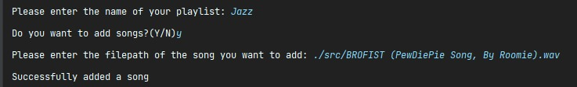

The above is how one would create a new playlist and what happens.

Viewing your playlist:

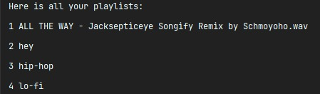

The above image is a view of all the playlists in one area created by a user. This is how all the playlists would appear.

Playing a song:

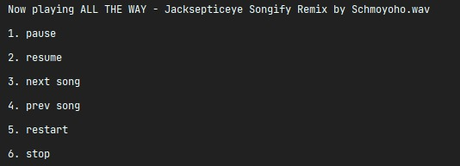

This is the view you would get when you are playing a song from any of your playlists.

Options to choose from:

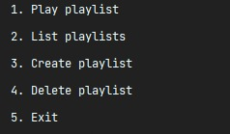

This is what one can do with the playlists you have already created.

Deleting a playlist:

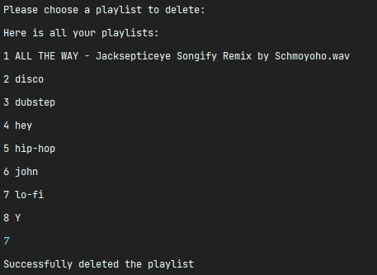

This is what happens when somebody wants to delete their playlist.

Adding a song to a playlist:

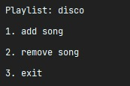

This is how a song is added to the playlists.

**Roles played by team members**

|  |  |
| --- | --- |
| Name + Surname | Role played |
| Justina Mateus | Created the flowchart |
| Thierry Katjindi | Typed the documentation |
| Prince Luiperth | Worked on the functions |
| Zinedine | Came up with the pseudocode |
| Eclah Kruger | Worked on the functions |
| Vitjitua Kahungi | Worked on the modules |